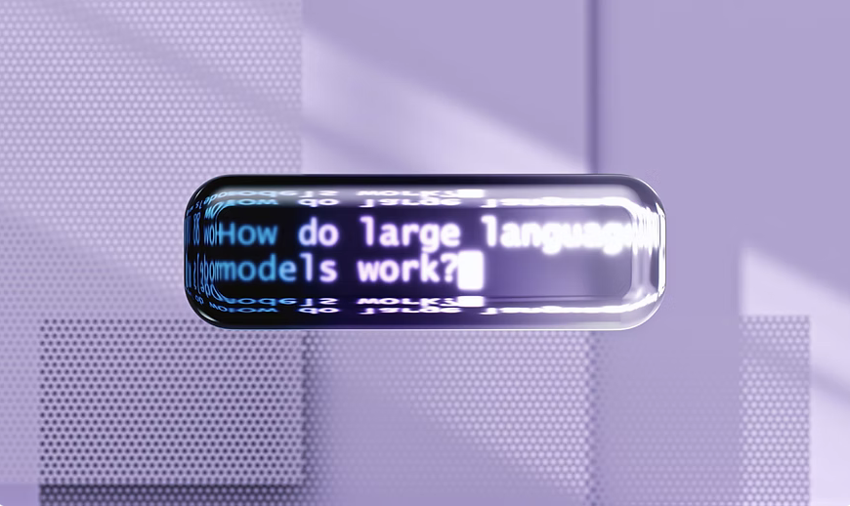
AI vs Human Creativity
Mon, Apr 27 | Vergani Löwenplatz
Can we touch a new way of being creative? As AI learns to paint, write, and compose, what defines human originality in the age of algorithms?
Registration is closed

TIME & LOCATION
Apr 27, 2026, 7:00 PM – 10:30 PM
Vergani Löwenplatz, Seidengasse 15, 8001 Zürich, Switzerland
ABOUT THE EVENT
When AI can generate it all, what’s left for you to create?
POP Impact Lab brings together researchers, artists and curious minds for an evening exploring the intersection of art, artificial intelligence and human creativity.

The night begins with a welcome apero, creating space for conversation and connection. This is followed by two short talks that dive into the creative and philosophical questions surrounding generative AI and human creativity:
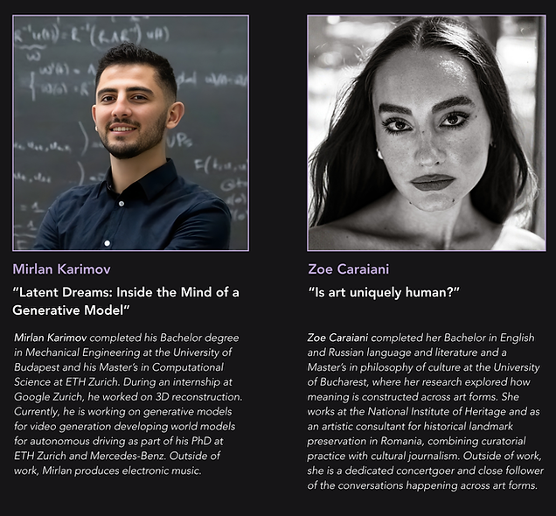

After the talks, the evening opens into a more immersive experience where art and music unfold live throughout the night.
Artist Rhytm will create a live painting, translating the themes of the discussion into visual form in real time.
At the same time, Mihai Barascu will take over the soundscape with a DJ set running through the evening, turning the space into a place where ideas continue through music, movement and conversation.
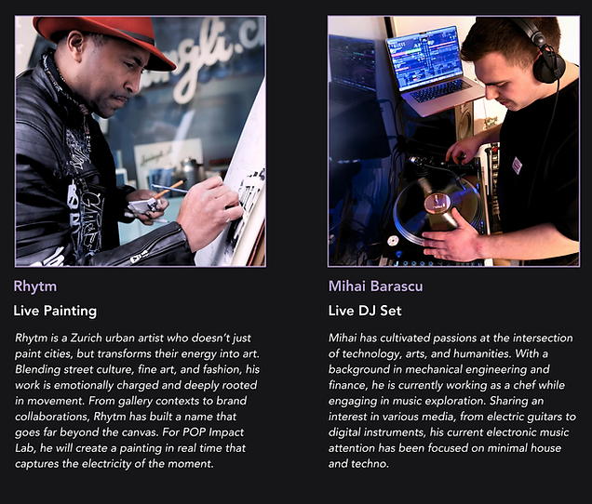
rhytmdenim.com

From research to art, from discussion to dance, the evening invites everyone to reflect, create and connect.

Event Flow
19:00 — Welcome Apéro
Arrival, food&drinks and informal networking

20:00 — Talks
- Latent Dreams: Inside the Mind of a Generative Model - Mirlan Karimov
- Is Art Uniquely Human? - Zoe Caraiani

From 20:50 — Live Art & Music
- Live Painting by Rhytm
- DJ Set by Mihai Barascu

Music, conversations and dancing throughout the evening.

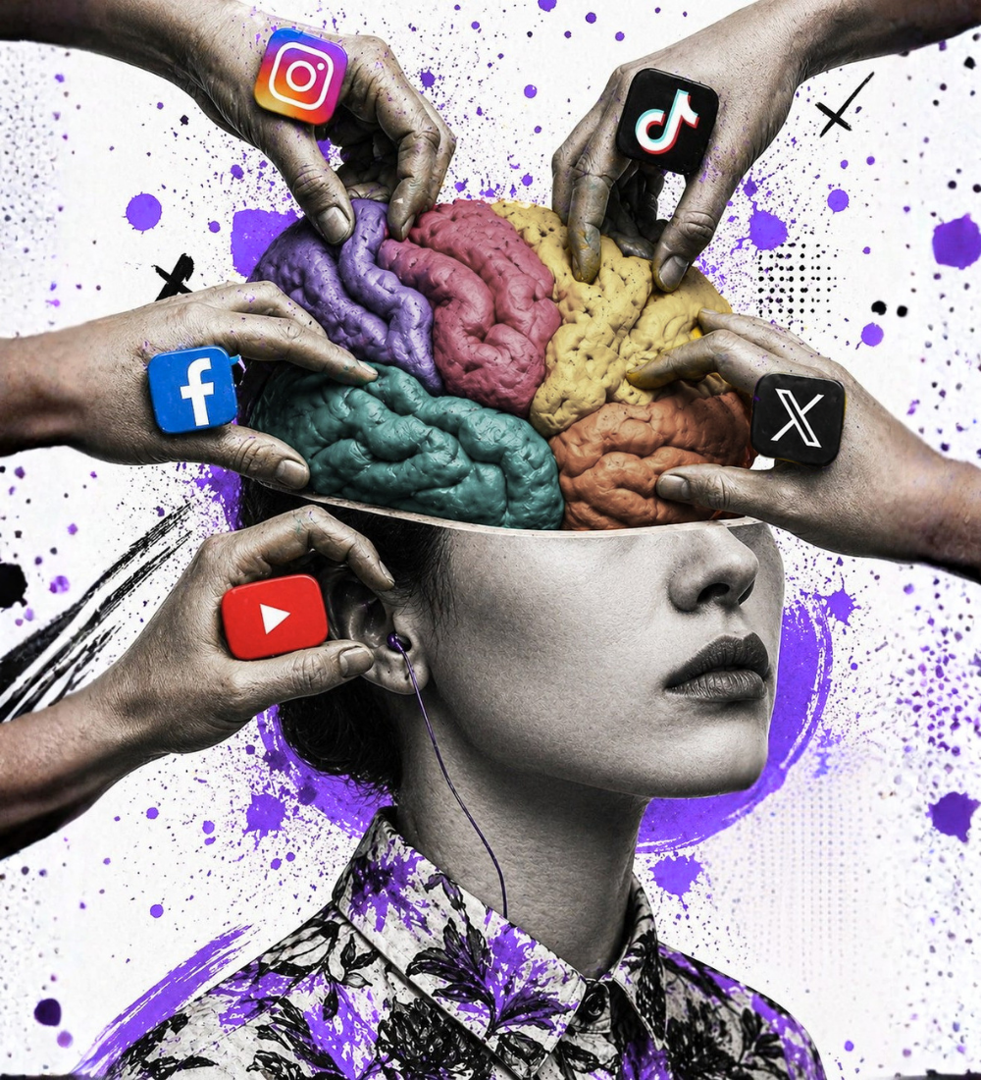

Social Media & How it changes your Mind
September 2026 (TBD) | Zürich
Where does influence end and manipulation begin? One speaker on how it works on the mind, one on what it does to society.

